ELEC 2210 Fall 2020

Lab 6 Quiz

Name: __________________________________

Section: _________________________________

1. For the circuit shown in Figure 1, find is the voltage across the resister a) when the value of the voltage source is +5V and b) when the value of the voltage source is -5V. (Assume that Von = 0.7 for the diodes.)

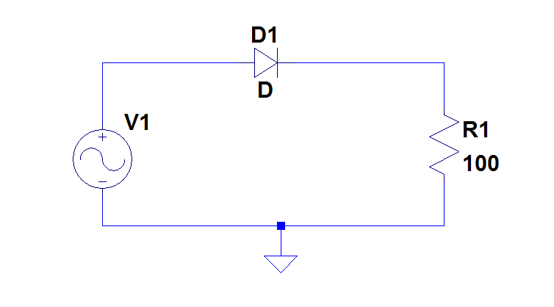

Figure 1

1. For the circuit shown in Figure 2, identify which diodes are conducting when the voltage source is positive.

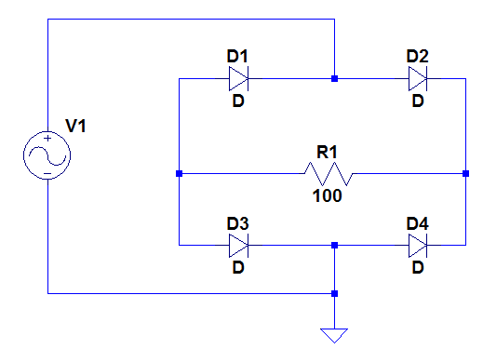

Figure 2